April 2020
4th Edition

WEB: WWW.ASK4CARE.COM | COMPLIMENTS OF ASK4CARE SUPPORT SERVICES INC.
ASK4CARE Employee of the Month for April is
Campbell Aigbuza

“Campbell Aigbuza – Personal Support worker at Ask4care Support Services Inc has incredible work ethic and an amazing attitude, never complaining and always smiling. She is a fabulous employee, a huge asset to Ask4Care Support Services Inc and is so deserving of this award and recognition.
Campbell is very flexible and always willing to do whatever is needed to get the done work. She has managed situations well in pressure conditions and client have appreciated her skills in managing the things in a Professional way. She is playing an important role in the continued relationship between Ask4Care Support Services and the Client.

We wish you all the best & keep up the good Work!

3

Quinoa and veggie casserole

Healthy Food

Get a plateful of colour from this comforting casserole made with quinoa and vegetables. The melted cheese topping with its crispy edges makes it simply irresistible.

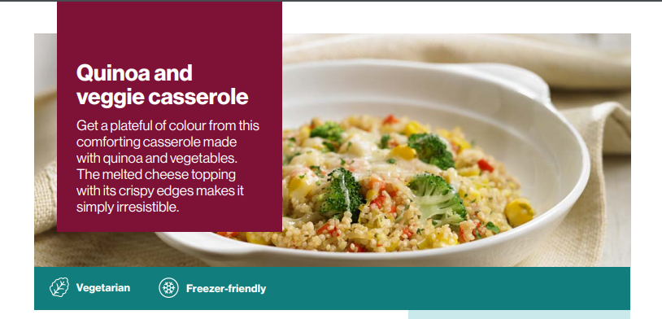

INGREDIENTS
PREP TIME 15 Min TOTAL TIME 35 Min SERVES: 5

- 10 mL (2 tsp) extra virgin olive oil
- 1 leek, white and light green part only, thinly sliced
- 3 cloves garlic, minced
- 1 red, orange, or yellow bell pepper, chopped
- 10 mL (2 tsp) Italian herb seasoning
- 250 mL (1 cup) quinoa, rinsed
- 500 mL (2 cups) broccoli florets
- 425 mL (1 3/4 cups) sodium reduced vegetable broth
- 250 mL (1 cup) corn kernels
- 175 mL (3/4 cup) shredded light old Cheddar cheese
- 15 mL (1 tbsp) chopped fresh parsley

DIRECTIONS

- In a large non-stick skillet heat oil over medium heat and cook leek, garlic, red pepper, and Italian herb seasoning for 5 minutes or until starting to soften. Stir in quinoa, broccoli, and vegetable broth. Bring to a boil; reduce heat to low and cover and cook for about 15 minutes or until quinoa is tender. Stir in corn and cook for 5 minutes.
- Spoon mixture into small casserole dish and sprinkle with cheese and parsley. Bake in preheated 200°C (400°F) oven for about 10 minutes or until cheese is melted.

Please Stay Home and Stay Healthy

References
https://www.canada.ca/en/health-canada/services/canada-food-guide/tips-healthy-eating/meal-planning-cooking-healthy-choices/recipes/quick-quinoa-veggie-casserole.html

